# Lab: Lists

Problems for exercises and homework for the ["Programming Fundamentals" course @ SoftUni](https://softuni.bg/courses/programming-fundamentals)

You can check your solutions in [Judge.](https://judge.softuni.bg/Contests/1295)

## Sum Adjacent Equal Numbers

Write a program to **sum all adjacent equal numbers** in a list of decimal numbers, starting from **left to right**.

* After two numbers are summed, the obtained result could be equal to some of its neighbors and should be summed as well (see the examples below).
* Always sum the **leftmost** two equal neighbors (if several couples of equal neighbors are available).

### Examples

|  |  |  |
| --- | --- | --- |
| **Input** | **Output** | **Explanation** |
| 3 3 6 1 | 12 1 | **3 3** 6 1 🡪 **6 6** 1 🡪 12 1 |
| 8 2 2 4 8 16 | 16 8 16 | 8 **2 2** 4 8 16 🡪 8 **4 4** 8 16 🡪 **8 8** 8 16 🡪 16 8 16 |
| 5 4 2 1 1 4 | 5 8 4 | 5 4 2 **1 1** 4 🡪 5 4 **2 2** 4 🡪 5 **4 4** 4 🡪 5 8 4 |
| 0.1 0.1 5 -5 | 0.2 5 -5 | **0.1 0.1** 5 -5 🡪 0.2 5 -5 |

### Solution

Read a list from numbers.

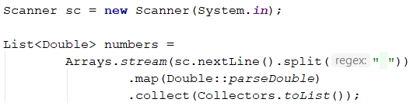

Iterate through the elements. Check if the number at the current index is equal to the next number. If it is, aggregate the numbers and reset the loop, otherwise don't do anything.

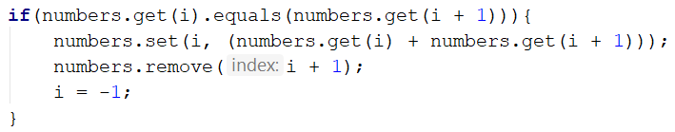

Finally, you have to print the numbers joined by space.



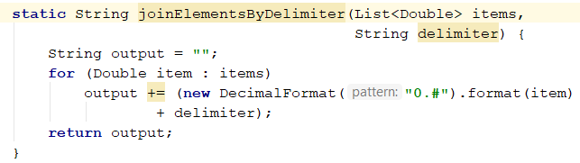

**import** java.text.DecimalFormat;  
**import** java.util.ArrayList;  
**import** java.util.List;  
**import** java.util.Scanner;  
  
**public class** SumAdjacentEqualNumbers {  
 **public static void** main(String[] args) {  
 Scanner scanner = **new** Scanner(System.***in***);  
  
 String line = scanner.nextLine();  
 String[] split = line.split(**" "**);  
  
 List<Double> numbers = **new** ArrayList<>();  
 **for** (**int** i = 0; i < split.**length**; i++) {  
 Double num = Double.*parseDouble*(split[i]);  
  
 numbers.add(num);  
 }  
  
 *// numbers -> {3, 3, 6, 1}* **for** (**int** i = 0; i < numbers.size() - 1; i++) {  
 **if** (numbers.get(i).equals(numbers.get(i + 1))) {  
 **double** sum = numbers.get(i) * 2;  
 numbers.remove(i); *// {3, 6, 1}* numbers.set(i, sum); *//{6, 6, 1}* i = - 1;  
 }  
 }  
 **for** (Double number : numbers) {  
 System.***out***.print(**new** DecimalFormat(**"0.#"**).format(number) + **" "**);  
 }  
 }  
}

## Gauss' Trick

Write a program that **sum** all **numbers in a list** in the following order:

first **+** last, first + 1 **+** last - 1,first + 2 **+** last **-** 2**,** … first + n, last - n.

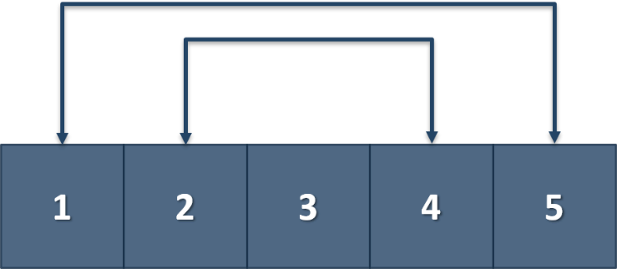

### Example

|  |  |
| --- | --- |
| **Input** | **Output** |
| 1 2 3 4 5 | 6 6 3 |
| 1 2 3 4 | 5 5 |

**import** java.util.ArrayList;  
**import** java.util.List;  
**import** java.util.Scanner;  
  
**public class** GaussTrick {  
 **public static void** main(String[] args) {  
 Scanner scanner = **new** Scanner(System.***in***);  
 String[] inputNumbers = scanner.nextLine().split(**" "**);  
 List<Integer> numbers = **new** ArrayList<>();  
  
 **for** (**int** i = 0; i < inputNumbers.**length**; i++) {  
 **int** current = Integer.*parseInt*(inputNumbers[i]);  
 numbers.add(current);  
 }  
 **int** iterationCount = numbers.size() / 2;  
  
 **for** (**int** i = 0; i < iterationCount ; i++) {  
 **int** lastIndex = numbers.size() - 1;  
 **int** currentSum = numbers.get(i) + numbers.get(lastIndex);  
  
 numbers.remove(lastIndex);  
 numbers.set(i, currentSum);  
 }  
 **for** (Integer number : numbers) {  
 System.***out***.print(number + **" "**);  
 }  
  
 }  
}

## Merging Lists

You are going to receive two lists with numbers. Create a result list which contains the numbers from both of the lists. The first element should be from the first list, the second from the second list and so on. If the length of the two lists are not equal, just add the remaining elements at the end of the list.

### Example

|  |  |
| --- | --- |
| **Input** | **Output** |
| 3 5 2 43 12 3 54 10 23  76 5 34 2 4 12 | 3 76 5 5 2 34 43 2 12 4 3 12 54 10 23 |
| 76 5 34 2 4 12  3 5 2 43 12 3 54 10 23 | 76 3 5 5 34 2 2 43 4 12 12 3 54 10 23 |

### Hint

* Read the two lists
* Create a result list
* Start looping through them until you reach the end of the smallest one
* Finally add the remaining elements (if any) to the end of the list

**import** java.util.ArrayList;  
**import** java.util.Arrays;  
**import** java.util.List;  
**import** java.util.Scanner;  
**import** java.util.stream.Collectors;  
  
**public class** MergingLists {  
 **public static void** main(String[] args) {  
 Scanner scanner = **new** Scanner(System.***in***);  
  
 List<Integer> left = *readList*(scanner);  
 List<Integer> right = *readList*(scanner);  
  
 List<Integer> result = **new** ArrayList<>();  
  
 **int** i = 0;  
 **while** (i < left.size() && i < right.size()) { *// for (i = 0; i < left.size(0) && i < right.size(); i++) {* result.add(left.get(i));  
 result.add(right.get(i));  
 i++;  
 }  
 **if** (i < left.size()) {  
 **for** (**int** j = i; j < left.size(); j++) {  
 result.add(left.get(j));  
 }  
  
 } **else if** (i < right.size()) {  
 **for** (**int** j = i; j < right.size(); j++) {  
 result.add(right.get(j));  
 }  
 }  
  
 **for** (Integer number : result) {  
 System.***out***.print(number + **" "**);  
 }  
 }  
  
 **private static** List<Integer> readList(Scanner scanner) {  
 String[] split = scanner.nextLine().split(**" "**);  
  
 *// "3" "4" "5";  
 // 3 4 5;* List<Integer> result =  
 Arrays.*stream*(split)  
 .map(Integer::*parseInt*).collect(Collectors.*toList*());  
 **return** result;  
  
 }  
}

## List Manipulation Basics

Write a program that reads a list of integers. Then until you receive **"end"**, you will be given different **commands:**

**Add {number}:** add a number to the end of the list

**Remove {number}:** remove a number from the list

**RemoveAt {index}:** remove a number at a given index

**Insert {number} {index}:** insert a number at a given index

**Note: All the indices will be valid!**

When you receive the **"end"** command print the **final state** of the list (**separated by spaces**)

### Example

|  |  |
| --- | --- |
| **Input** | **Output** |
| 4 19 2 53 6 43  Add 3  Remove 2  RemoveAt 1  Insert 8 3  end | 4 53 6 8 43 3 |

### Solution

First let us read the list from the console.

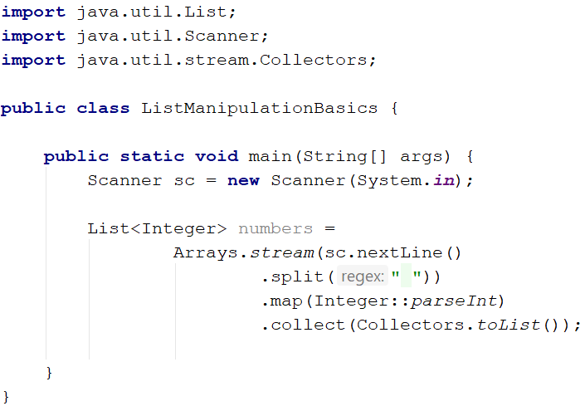

Next we make the while loop for the commands and make switch statement for the commands

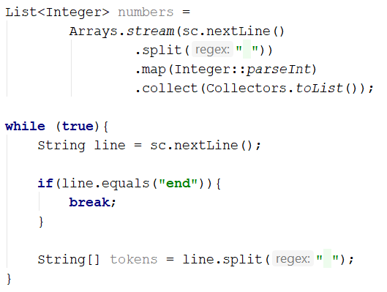

We break if the line is "end", otherwise we split it into tokens and process the command.

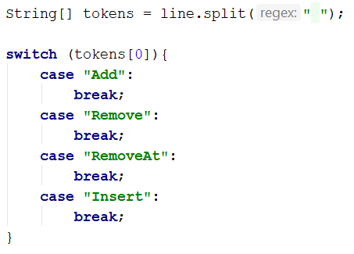

Now let's implement each command.

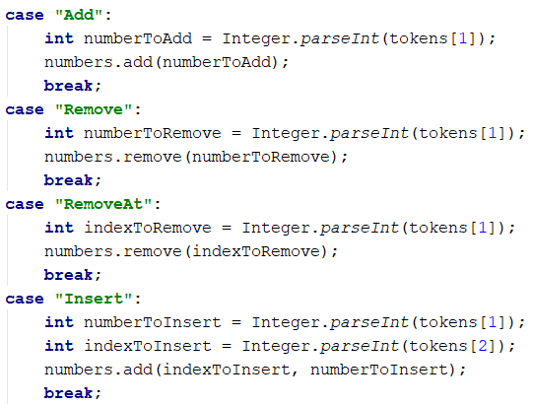

For all commands **except from** the **"Insert",** **tokens[1]** is the **number/index**. For the **"Insert"** command we receive a **number and an index** (**tokens[1], tokens[2]**)

Finally, we **print** the numbers, joined by **a single space**

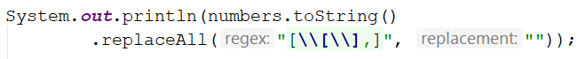

## List Manipulation Advanced

Now we will implement more complicated list commands. Again, read a list, and until you receive **"end"** read commands:

**Contains {number}** – check if the list contains the number. If **yes** print **"Yes**", **otherwise** print **"No such number"**

**Print even** – print **all the numbers** that are **even** **separated by a space**

**Print odd** – print **all the numbers** that are **odd separated by a space**

**Get sum** – print the **sum of all the numbers**

**Filter ({condition} {number})** – print all the numbers that **fulfill that condition**. The condition will be either **'<'**, **'>', ">=", "<="**

### Example

|  |  |
| --- | --- |
| **Input** | **Output** |
| 2 13 43 876 342 23 543  Contains 100  Contains 543  Print even  Print odd  Get sum  Filter >= 43  Filter < 100  end | No such number  Yes  2 876 342  13 43 23 543  1842  43 876 342 543  2 13 43 23 |

## List of products

Read a number **n** and **n lines of products**. Print a **numbered list** of all the products **ordered by name**.

### Examples

|  |  |
| --- | --- |
| **Input** | **Output** |
| 4  Potatoes  Tomatoes  Onions  Apples | 1.Apples  2.Onions  3.Potatoes  4.Tomatoes |

### Solution

First, we need to read the number **n** from the console

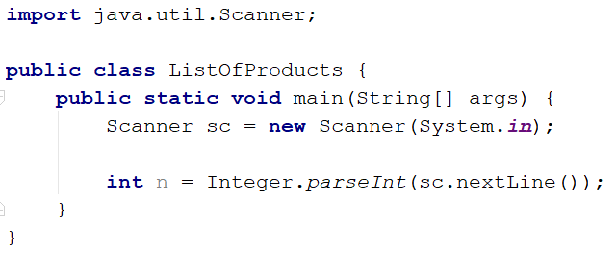

Then we need to create our **list of strings**, because the **products are strings**

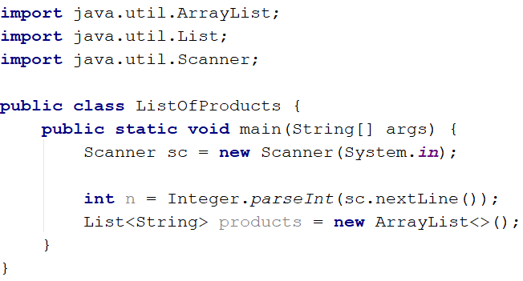

Then we need to iterate **n times** and **read products**.

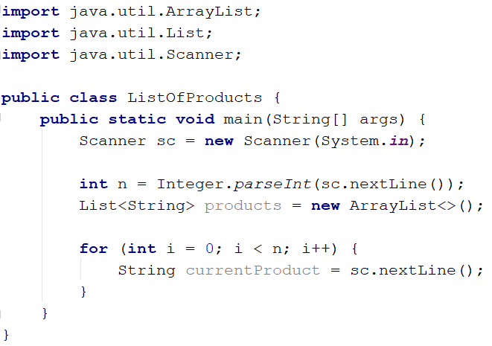

The next step is to add the current product to the list

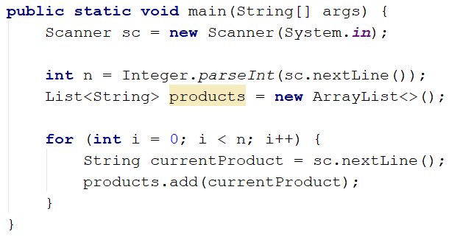

After we finish reading the products we **sort our list alphabetically**

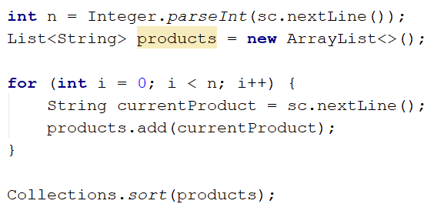

The **sort method** sorts the list in ascending order.

Finally, we have to **print our sorted** list. To do that we **loop through the list**.

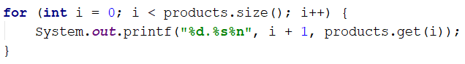

We use **i + 1**, because we want to **start counting from 1**.

**import** java.util.ArrayList;  
**import** java.util.Collections;  
**import** java.util.List;  
**import** java.util.Scanner;  
  
**public class** ListOfProducts {  
 **public static void** main(String[] args) {  
 Scanner scanner = **new** Scanner(System.***in***);  
 **int** n = Integer.*parseInt*(scanner.nextLine());  
  
 List<String> products = **new** ArrayList<>();  
 **for** (**int** i = 0; i < n; i++) {  
 String current = scanner.nextLine();  
  
 products.add(current);  
 }  
  
 Collections.*sort*(products);  
 **for** (**int** i = 0; i < products.size(); i++) {  
 System.***out***.println((i + 1) + **"."** + products.get(i));  
 }  
 }  
  
 **private static void** printList(List<String> lines) {  
 **for** (String item : lines) {  
 System.***out***.println(item);  
 }  
 }  
}

## Remove Negatives and Reverse

Read a **list of integers**, **remove all negative numbers** from it and print the remaining elements in **reversed order**. In case of no elements left in the list, print "empty".

### Examples

|  |  |
| --- | --- |
| **Input** | **Output** |
| 10 -5 7 9 -33 50 | 50 9 7 10 |
| 7 -2 -10 1 | 1 7 |
| -1 -2 -3 | empty |

### Solution

Read a list of integers.

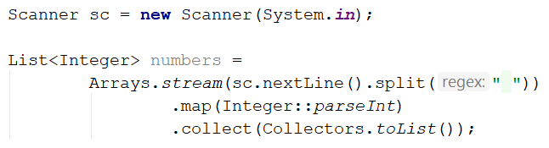

Remove all negative numbers and reverse the collection.



If the list is empty print "empty", otherwise print all numbers joined by space.

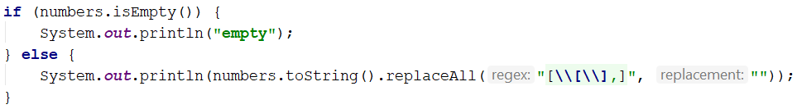

**import** java.util.Arrays;  
**import** java.util.Collections;  
**import** java.util.List;  
**import** java.util.Scanner;  
**import** java.util.stream.Collectors;  
  
**public class** RemoveNegativesAndReverse {  
 **public static void** main(String[] args) {  
 Scanner scanner = **new** Scanner(System.***in***);  
  
 String[] parts = scanner.nextLine().split(**" "**);  
  
 List<Integer> numbers = Arrays.*stream*(parts)  
 .map(Integer::*parseInt*)  
 .collect(Collectors.*toList*());  
  
 **for** (**int** i = 0; i < numbers.size(); i++) {  
 **if** (numbers.get(i) < 0) {  
 numbers.remove(i);  
 i--;  
 }  
 }  
 Collections.*reverse*(numbers);  
 **if** (numbers.size() == 0) {  
 System.***out***.println(**"empty"**);  
 } **else** {  
 *printList*(numbers);  
 }  
 }  
  
 **private static void** printList(List<Integer> lines) {  
 **for** (Integer item : lines) {  
 System.***out***.print(item + **" "**);  
 }  
 }  
}